Contributor: Imma Ramos

**Yllanes, Alejandro Mario**

Born: 1913 – Oruro, Bolivia; Died: 1960 – Mexico

Alejandro Mario Yllanes was a Bolivian Aymara painter, engraver and muralist. His art career began with an exhibition in his hometown of Oruro in 1930, when he was nineteen years old. Shortly afterwards he moved to La Paz where he worked as an illustrator for the periodical, *Semana Grafica*, during which time he became acquainted with the artists Arturo Borda and **Cecilio** Guzmán **de Rojas**. All three Bolivian artists were influenced by the so-called *indigenism* or *indigenismo* movement which gained momentum in Latin America from the 1920s onwards. The movement was characterised by the promotion of national pride and a nostalgic celebration of the Inca and pre-Columbian past, reflected in literature and the visual arts. Yllanes was driven by a desire to encourage a spirit of community amongst the native Bolivians and his works often portray locals in traditional Andean dress, carrying out pre-conquest rituals and customs. His incorporation of styles and techniques influenced by Post-Impressionism, Cubism and Mexican Muralism show his engagement with Modernist trends. The latter movement was headed by Diego Rivera, JoséClemente Orozco and David Alfaro Siqueiros. Their socio-political art, inspired by the Mexican Revolution, fuelled Yllanes’s own work, which he combined with a rootedness to local narrative and materials.

Yllanes was inspired by Bolivia’s pre-Columbian history. His *Dance of the Plough* (1940) takes pride in Andean agricultural heritage in particular. His very use of material is rooted in the earth: most of his paintings are executed on burlap. The work, with its dynamic use of line and colour, pulsates with energy. In scenes of carnival such as *Carnival in the Mountain Peaks* (1940s) and *Wirakhocha Dancer* (1941), Bolivian dancers and musicians engage in riotous displays of ritual and revelry. The stylised figures twist and turn, evoking the rhythm of music. He also represented Inca dancers and deities. The pre-Hispanic past, particularly the Inca Empire, was idealised by many *indigenistas* including Yllanes who envisioned it as a period of harmony and prosperity that could be revived. The death of indigenous culture is signalled in *Death of an Indian Chief* (*Muerte de Willka*) (1944).

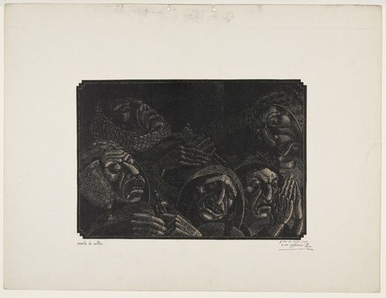

Alejandro Mario Yllanes, *Death of an Indian Chief*, 1944, wood engraving, Museum of Modern Art (New York).

Source: <http://www.moma.org/collection/object.php?object_id=64242>

While his paintings were a platform for celebrating indigenous culture, his dark wood engravings often served as a platform for social commentary. Abject misery and poverty is rendered through an expressionistic visual idiom in *Pongos (Poor Indians)* (1944) while *Trinchera* *(Trenches of Bolivia and Paragway War-Chaco)* (1944) is stark in its rendering of skulls, one grimly wearing a traditional Andean hat. It evokes the thousands of indigenous people who died during the Gran Chaco War (1932-35) between Paraguay and Bolivia. Yllanes also drew in graphite, charcoal and ink. His caricature entitled *Nouveaux Riches* (c.1937, graphite on paper) represents a wealthy, bespectacled man wearing a suit, who is drawn in the form of a pig stabbing a knife into a bleeding representation of land.

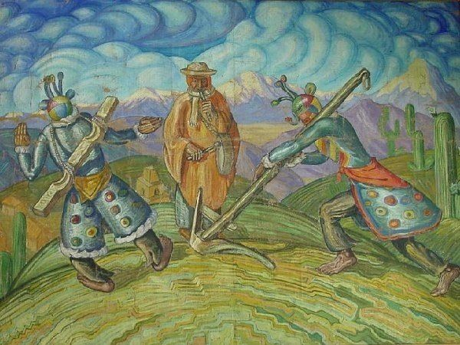

Alejandro Mario Yllanes, *Dance of the Plough*, 1944, oil on burlap, Peyton Wright Gallery (Santa Fe).

Source: <http://www.masterpieceonline.com/title.php?ititlenum=1368&galleryId=1CB1-DGAH-6E59>

From 1934 to 1935 Yllanes taught and painted at the Ayllu School of Warisata, which was founded with the intention of educating indigenous children about their own local traditions and crafts in order to preserve them. Yllanes created murals in tempera on the school’s walls which portrayed scenes of local life, including the ploughing of the land, leather workers, ferrymen transporting goods across Lake Titicaca, and other representations of Andean culture, as well as politically motivated imagery. In the 1940s, describing Warisata as an “experimental institute for Indian education,” Lilo Linke evoked one of these murals vividly:

*So intensely does Illanes think of himself as a leader of the masses that he painted himself as a public speaker in the biggest of his pictures, ‘The Tragedy of the Indian Slaves.’ It tells its own story. In the foreground are a group of Indians weighed down by enormous bundles on their backs. A Spanish conqueror holds his hand at the throat of another Indian. A Bolivian politician stands hand in hand with a priest. The U.S. flag waves over petrol wells. The British Empire, symbolized by an enormous eagle, is fighting against the condor of Tihuanacu, symbol of the Bolivian race. The only signs of hope are the faces turned up to the painter, now orator, and an Indian woman with a child in her arms. (…) [Illanes] belongs to the small group of violent revolutionaries, painting enormous pictures in the mood and technique of Diego Rivera, who has found enthusiastic disciples all over Latin America.*

During the 1940s, Yllanes served as a cultural attache to the Bolivian Embassy in Mexico. There he had a solo exhibition at the Palacio de Bellas Artes in 1946, for which **Diego Rivera** wrote an introduction for the show’s catalogue. Rivera championed him as “one of the greatest and most original of American painters (…) artists and workers of Mexico should open their arms to (…) this Bolivian who endured torture, languished in prison and suffered in exile because of the revolutionary affirmations expressed in his paintings.”

Yllanes subsequently settled in New York, and little is known of his life thereafter. He seemingly disappeared in 1946 after failing to claim a Guggenheim Fellowship, and it is believed he returned to Mexico. The date of his death is unknown; it is believed to be 1960, although his name continued to appear in *Who’s Who in American Art* until 1972.

**Further reading:**

Barnitz, J. (2000) *Twentieth-century art of Latin America*. Austin: University of Texas.

Betsy R. (1994) “Let's Bring the Yllanes Collection Home”, *Bolivian Times*. La Paz.

Linke, L. (1945) *Andean Adventure: a social and political study of Columbia, Ecuador and Bolivia*. London: Hutchinson and Co.

Raynor, V. (April 1992) “Art Works by a Vanished Bolivian Painter,” *New York Times.*

Weintraub, L. and Yllanes, A.M. (1992) *Being Discovered. The Spanish Conquest from the Amer-Indian Point of View,* New York: Edith C. Blum Art Institute, Bard College.

**List of Works:**

*Nouveaux Riches*, c.1937, graphite on paper, private collection.

*Wirakhocha Dancer*, 1941, oil on burlap, private collection.

*Carnival in the Mountain Peaks*, 1940s, oil on burlap, private collection.

*Death of an Indian Chief*, 1944, wood engraving, Museum of Modern Art (New York).

*Dance of the Plough*, 1944, oil on burlap, Peyton Wright Gallery (Santa Fe).

*Pongos (Poor Indians)*, 1944, wood engraving, private collection.

*Trinchera* *(Trenches of Bolivia and Paragway War-Chaco)*, 1944, wood engraving, private collection.

*Self-portrait Number 1*, 1944, wood engraving, private collection.